TO :

Date : Aug., 08, 2013

HannStar Product Specification
(Formal)

Model: HSD070IFW1-A00
(Module)

Note:

- Please contact HannStar Display Corp. before designing your product based on this module specification.
- The information contained herein is presented merely to indicate the characteristics and performance of our products. No responsibility is assumed by HannStar for any intellectual property claims or other problems that may result from application based on the module described herein.

Record of Revisions
Rev. | Date | Sub-Model | Description of change
1.0  1.1 | May, 07, 2013  Aug, 08, 2013 | A00  A00 | Formal Product Specification was first released.  P4. Modify Surface treatment

Contents

1.0 General description ………………………………… p.4
2.0 Absolute maximum ratings……………………………. p.5
3.0 Optical characteristics.………………………………. p.6
4.0 Block diagram ……………………………………… p.10
5.0 Interface pin connection …………………………… p.13
6.0 Electrical characteristics …………………………… p.15
7.0 Reliability test items ………………………………… p.20
8.0 Outline dimension …………………………………… p.21
9.0 Lot mark ……………………………………………... p.23
10.0 Package specification ……………………………… p.24
11.0 General precaution …………………………………… p.25

- GENERAL DESCRIPTION
  - Introduction
HannStar Display model HSD070IFW1-A is a color active matrix thin film transistor (TFT) liquid crystal display (LCD) that uses amorphous silicon TFT as a switching device. This model is composed of a TFT LCD panel, a driving circuit and a back light system. This TFT LCD has a 7.0 (16:9) inch diagonally measured active display area with WSVGA (1024 horizontal by 600 vertical pixel) resolution.
  - Features
- 7 inch (16:9 diagonal) configuration
- 16.7M color by 6 bit+HiFRC R.G.B signal input
- RoHS/ Halogen Free Compliance
  - Applications
- Automotive
  - TFT LCD General information
Item |  | Specification | Unit
Outline Dimension |  | 164.9 x 100.0 (typ) | mm
Display area |  | 153.6(H) x 86.64(V) | mm
Number of Pixel |  | 1024 RGB (H) x 600(V) | pixels
Pixel pitch |  | 0.150(H) x 0.1444(V) | mm
Pixel arrangement |  | RGB Vertical stripe
Display mode |  | Normally white
NTSC |  | 50 (typ.) | %
Surface treatment |  | AG, with EWV Flim
Weight |  | 146g (Typ.) | g
Back-light |  | White LED
Power Consumption | Logic | 0.35 (typ) @ Black pattern、Frame rate 60Hz | W
Power Consumption | BL System | 2.45 (typ) @ Black pattern w/o LED driver | W

1.5 Mechanical Information
Item |  | Min. | Typ. | Max. | Unit
Module  Size | Horizontal (H) | 164.6 | 164.9 | 165.2 | mm
Module  Size | Vertical (V) | 99.7 | 100.0 | 100.3 | mm
Module  Size | Depth (D) | 5.4 | 5.7 | 6.0 | mm
Module  Size | Depth (with component) |  |  | 7.3 | mm
Weight |  | － | 146 | 156 | －

- ABSOLUTE MAXIMUM RATINGS
  - Electrical Absolute Rating
    - TFT LCD Module
Item | Symbol | Min. | Max. | Unit | Note
Power supply voltage | V_{DD} | -0.3 | 5.0 | V
Power supply voltage | V_{GH} | -0.3 | 40.0 | V
Power supply voltage | V_{GL} | -20.0 | 0.3 | V
Power supply voltage | AV_{DD} | 6.5 | 13.5 | V
Power supply voltage | V_{I} | -0.3 | V_{DD} +0.3 | V
Logic Signal Input Level | V_{DD} | -0.3 | 5.0 | V

    - Backlight unit
Item | Symbol | Typ. | Max. | Unit | Note
LED current | I_{L} | 240 | - | mA | (1) (2)(3)
LED voltage | V_{L} | 9.6 | 10.2 | V | (1) (2)(3)
LED reverse voltage | V_{R} | -- | 5 | V

Note:
- Permanent damage may occur to the LCD module if beyond this specification.
Functional operation should be restricted to the conditions described under
normal operating conditions.
- Ta =25±2℃
- Test Condition: LED current 240 mA. The LED lifetime could be decreased if operating IL is larger than 240 mA.

    - Environment Absolute Rating

Item | Symbol | Min. | Max. | Unit | Note
Operating Temperature | T_{opa} | -20 | 70 | ℃
Storage Temperature | T_{stg} | -30 | 80 | ℃

- OPTICAL CHARACTERISTICS
  - Optical specification
Item |  | Symbol | Condition | Min. | Typ. | Max. | Unit | Note
Contrast |  | CR | Θ=0  Normal  viewing  angle | 640 | 800 | － |  | (1)(2)(4)
Response time |  | Tr | Θ=0  Normal  viewing  angle | － | 4 | 8 | msec | (1)(3)
 |  | Tf | Θ=0  Normal  viewing  angle | － | 12 | 24 | msec | (1)(3)
White luminance  (Center) |  | Y_{L} | Θ=0  Normal  viewing  angle | 480 | 600 | － | cd/m² | (1)(4)  (I_{L}=240mA)
Color chromaticity  (CIE1931) | Red | R_{x} | Θ=0  Normal  viewing  angle | -0.05 | 0.617 | +0.05
Color chromaticity  (CIE1931) | Red | R_{Y} | Θ=0  Normal  viewing  angle | -0.05 | 0.353 | +0.05
Color chromaticity  (CIE1931) | Green | G_{x} | Θ=0  Normal  viewing  angle | -0.05 | 0.365 | +0.05
Color chromaticity  (CIE1931) | Green | G_{Y} | Θ=0  Normal  viewing  angle | -0.05 | 0.580 | +0.05
Color chromaticity  (CIE1931) | Blue | B_{x} | Θ=0  Normal  viewing  angle | -0.05 | 0.148 | +0.05
Color chromaticity  (CIE1931) | Blue | B_{Y} | Θ=0  Normal  viewing  angle | -0.05 | 0.098 | +0.05
Color chromaticity  (CIE1931) | White | W_{x} | Θ=0  Normal  viewing  angle | -0.05 | 0.31 | +0.05
Color chromaticity  (CIE1931) | White | W_{y} | Θ=0  Normal  viewing  angle | -0.05 | 0.33 | +0.05
Viewing angle | Hor. | Θ_{L} | CR>10 | 70 | 80 | － |  | (1)(4)
Viewing angle | Hor. | Θ_{R} | CR>10 | 70 | 80 | － |  | (1)(4)
Viewing angle | Ver. | Θ_{U} | CR>10 | 60 | 70 | － |  | (1)(4)
Viewing angle | Ver. | Θ_{D} | CR>10 | 70 | 80 | － |  | (1)(4)
Brightness uniformity |  | B_{UNI} | Θ=0  (9point) | 70 | 75 | － |  | (5)
View Direction |  | 6 O’clock |  |  |  |  |  | (6)

  - Measuring Condition
- Measuring surrounding：dark room
- LED current I_{L}: 240mA
- Ambient temperature：25±2ºC
- 15min. warm-up time.

  - Measuring Equipment
- FPM520 of Westar Display technologies, INC., which utilized SR-3 for Chromaticity and BM-5A for other optical characteristics.
- Measuring spot size：20 ~ 21 mm
Note (1) Definition of Viewing Angle:

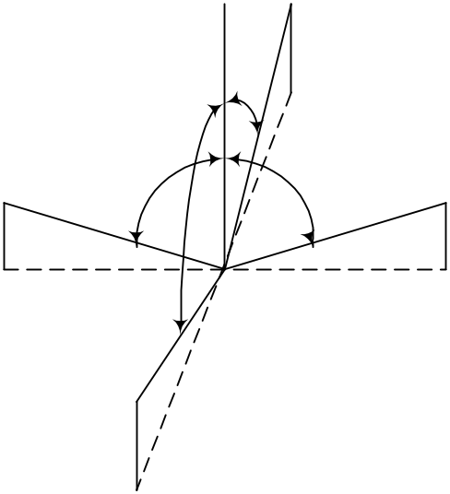
Θ_{L}
Θ_{R}
Θ_{U}
Θ_{D}
Φ=0º
Φ=180º
12’ o’clock
Φ=90º

6’ o’clock
Φ=270º

Note (2) Definition of Contrast Ratio (CR) :
measured at the center point of panel

Luminance with all pixels white
CR =
Luminance with all pixels black

Note (3) Definition of Response Time : Sum of T_{R} and T_{F}

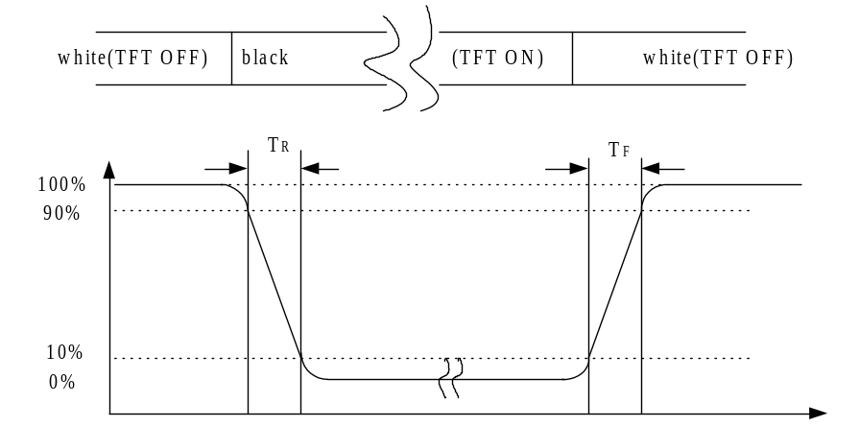
time
Optical response

Note (4) Definition of optical measurement setup

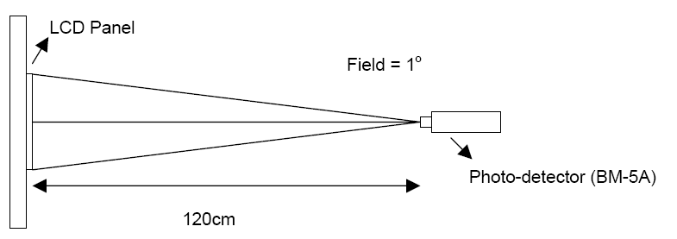

Note (5) Definition of Average Luminance Uniformity of White (Center)
Definition of brightness uniformity

16.7%
50%
83.3%

16.7%
50%
83.3%
Y₁
Y₂
Y₃
Y₄
Y₅
Y₆
Y₇
Y₈
Y₉

(Min Luminance of 9 points)
(Max Luminance of 9 points)

Luminance uniformity = x100%

Note (6) Rubbing Direction (The different Rubbing Direction will cause the different
optimal view direction.)

  - BLOCK DIAGRAM
  - TFT LCD Module
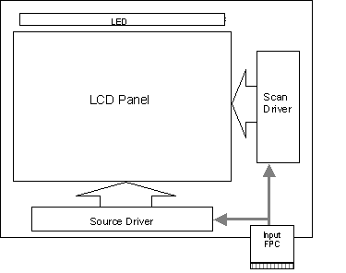
CN1

  - Pixel Format

1,1
1,1024
1,2
1,3
1,4
R
R
R
B
G
1 Pixel

2,1
LCD Display Area

600 Lines

600,
1024
600,1

1024 pixel (3072 Dots)

4.3 Relationship Between Displayed Color and Input
4.3.1 6bit
 | Display | MSB LSB  R5 R4 R3 R2 R1 R0 | MSB LSB  G5 G4 G3 G2G1 G0 | MSB LSB  B5 B4 B3 B2 B1 B0 | Gray scale level
Basic color | Black | LLLLLL | LLLLLL | LLLLLL | -
Basic color | Blue | LLLLLL | LLLLLL | HHHHHH | -
Basic color | Green | LLLLLL | HHHHHH | LLLLLL | -
Basic color | Light Blue | LLLLLL | HHHHHH | HHHHHH | -
Basic color | Red | HHHHHH | LLLLLL | LLLLLL | -
Basic color | Purple | HHHHHH | LLLLLL | HHHHHH | -
Basic color | Yellow | HHHHHH | HHHHHH | LLLLLL | -
Basic color | White | HHHHHH | HHHHHH | HHHHHH | -
Gray scale  of Red | Black | LLLLLL | LLLLLL | LLLLLL | L0
Gray scale  of Red | Dark  ↑  ↓  Light | LLLLLH | LLLLLL | LLLLLL | L1
Gray scale  of Red | Dark  ↑  ↓  Light | LLLLHL | LLLLLL | LLLLLL | L2
Gray scale  of Red | Dark  ↑  ↓  Light | : | : | : | L3…L60
Gray scale  of Red | Dark  ↑  ↓  Light | HHHHLH | LLLLLL | LLLLLL | L61
Gray scale  of Red | Dark  ↑  ↓  Light | HHHHHL | LLLLLL | LLLLLL | L62
Gray scale  of Red | Red | HHHHHH | LLLLLL | LLLLLL | Red L63
Gray scale of Green | Black | LLLLLL | LLLLLL | LLLLLL | L0
Gray scale of Green | Dark  ↑  ↓  Light | LLLLLL | LLLLLH | LLLLLL | L1
Gray scale of Green | Dark  ↑  ↓  Light | LLLLLL | LLLLHL | LLLLLL | L2
Gray scale of Green | Dark  ↑  ↓  Light | : | :  : | :  : | L3…L60
Gray scale of Green | Dark  ↑  ↓  Light | LLLLLL | HHHHLH | LLLLLL | L61
Gray scale of Green | Dark  ↑  ↓  Light | LLLLLL | HHHHHL | LLLLLL | L62
Gray scale of Green | Green | LLLLLL | HHHHHH | LLLLLL | Green L63
Gray scale of Blue | Black | LLLLLL | LLLLLL | LLLLLL | L0
Gray scale of Blue | Dark  ↑  ↓  Light | LLLLLL | LLLLLL | LLLLLH | L1
Gray scale of Blue | Dark  ↑  ↓  Light | LLLLLL | LLLLLL | LLLLHL | L2
Gray scale of Blue | Dark  ↑  ↓  Light | : | : | : | L3…L60
Gray scale of Blue | Dark  ↑  ↓  Light | LLLLLL | LLLLLL | HHHHLH | L61
Gray scale of Blue | Dark  ↑  ↓  Light | LLLLLL | LLLLLL | HHHHHL | L62
Gray scale of Blue | Blue | LLLLLL | LLLLLL | HHHHHH | Blue L63
Gray scale of White &  Black | Black | LLLLLL | LLLLLL | LLLLLL | L0
Gray scale of White &  Black | Dark  ↑  ↓  Light | LLLLLH | LLLLLH | LLLLLH | L1
Gray scale of White &  Black | Dark  ↑  ↓  Light | LLLLHL | LLLLHL | LLLLHL | L2
Gray scale of White &  Black | Dark  ↑  ↓  Light | : | : | : | L3…L60
Gray scale of White &  Black | Dark  ↑  ↓  Light | HHHHLH | HHHHLH | HHHHLH | L61
Gray scale of White &  Black | Dark  ↑  ↓  Light | HHHHHL | HHHHHL | HHHHHL | L62
Gray scale of White &  Black | White | HHHHHH | HHHHHH | HHHHHH | White L63

    - 8bit
 |  | MSB |  |  |  | LSB |  |  |  | MSB |  |  |  | LSB |  |  |  | MSB |  |  |  | LSB |  |  |  | Gray scale
 | Display | R7 | R6 | R5 | R4 | R3 | R2 | R1 | R0 | G7 | G6 | G5 | G4 | G3 | G2 | G1 | G0 | B7 | B6 | B5 | B4 | B3 | B2 | B1 | B0 | Level
Basic  color | Black | L | L | L | L | L | L | L | L | L | L | L | L | L | L | L | L | L | L | L | L | L | L | L | L | -
Basic  color | Blue | L | L | L | L | L | L | L | L | L | L | L | L | L | L | L | L | H | H | H | H | H | H | H | H | -
Basic  color | Green | L | L | L | L | L | L | L | L | H | H | H | H | H | H | H | H | L | L | L | L | L | L | L | L | -
Basic  color | Light Blue | L | L | L | L | L | L | L | L | H | H | H | H | H | H | H | H | H | H | H | H | H | H | H | H | -
Basic  color | Red | H | H | H | H | H | H | H | H | L | L | L | L | L | L | L | L | L | L | L | L | L | L | L | L | -
Basic  color | Purple | H | H | H | H | H | H | H | H | L | L | L | L | L | L | L | L | H | H | H | H | H | H | H | H | -
Basic  color | Yellow | H | H | H | H | H | H | H | H | H | H | H | H | H | H | H | H | L | L | L | L | L | L | L | L | -
Basic  color | White | H | H | H | H | H | H | H | H | H | H | H | H | H | H | H | H | H | H | H | H | H | H | H | H | -
Gray scale of Red | Black | L | L | L | L | L | L | L | L | L | L | L | L | L | L | L | L | L | L | L | L | L | L | L | L | L0
Gray scale of Red |  | L | L | L | L | L | L | L | H | L | L | L | L | L | L | L | L | L | L | L | L | L | L | L | L | L1
Gray scale of Red | Dark | L | L | L | L | L | L | H | L | L | L | L | L | L | L | L | L | L | L | L | L | L | L | L | L | L2
Gray scale of Red | ↑ | ︰ |  |  |  |  |  |  |  | ︰ |  |  |  |  |  |  |  | ︰ |  |  |  |  |  |  |  | L3…L251
Gray scale of Red | ↓ | H | H | H | H | H | H | L | L | L | L | L | L | L | L | L | L | L | L | L | L | L | L | L | L | L252
Gray scale of Red | Light | H | H | H | H | H | H | L | H | L | L | L | L | L | L | L | L | L | L | L | L | L | L | L | L | L253
Gray scale of Red |  | H | H | H | H | H | H | H | L | L | L | L | L | L | L | L | L | L | L | L | L | L | L | L | L | L254
Gray scale of Red | Red | H | H | H | H | H | H | H | H | L | L | L | L | L | L | L | L | L | L | L | L | L | L | L | L | Red L255
Gray scale of Green | Black | L | L | L | L | L | L | L | L | L | L | L | L | L | L | L | L | L | L | L | L | L | L | L | L | L0
Gray scale of Green |  | L | L | L | L | L | L | L | L | L | L | L | L | L | L | L | H | L | L | L | L | L | L | L | L | L1
Gray scale of Green | Dark | L | L | L | L | L | L | L | L | L | L | L | L | L | L | H | L | L | L | L | L | L | L | L | L | L2
Gray scale of Green | ↑ | ︰ |  |  |  |  |  |  |  | ︰ |  |  |  |  |  |  |  | ︰ |  |  |  |  |  |  |  | L3…L251
Gray scale of Green | ↓ | L | L | L | L | L | L | L | L | H | H | H | H | H | H | L | L | L | L | L | L | L | L | L | L | L252
Gray scale of Green | Light | L | L | L | L | L | L | L | L | H | H | H | H | H | H | L | H | L | L | L | L | L | L | L | L | L253
Gray scale of Green |  | L | L | L | L | L | L | L | L | H | H | H | H | H | H | H | L | L | L | L | L | L | L | L | L | L254
Gray scale of Green | Green | L | L | L | L | L | L | L | L | H | H | H | H | H | H | H | H | L | L | L | L | L | L | L | L | Green L255
Gray scale of Blue | Black | L | L | L | L | L | L | L | L | L | L | L | L | L | L | L | L | L | L | L | L | L | L | L | L | L0
Gray scale of Blue |  | L | L | L | L | L | L | L | L | L | L | L | L | L | L | L | L | L | L | L | L | L | L | L | H | L1
Gray scale of Blue | Dark | L | L | L | L | L | L | L | L | L | L | L | L | L | L | L | L | L | L | L | L | L | L | H | L | L2
Gray scale of Blue | ↑ | ︰ |  |  |  |  |  |  |  | ︰ |  |  |  |  |  |  |  | ︰ |  |  |  |  |  |  |  | L3…L251
Gray scale of Blue | ↓ | L | L | L | L | L | L | L | L | L | L | L | L | L | L | L | L | H | H | H | H | H | H | L | L | L252
Gray scale of Blue | Light | L | L | L | L | L | L | L | L | L | L | L | L | L | L | L | L | H | H | H | H | H | H | L | H | L253
Gray scale of Blue |  | L | L | L | L | L | L | L | L | L | L | L | L | L | L | L | L | H | H | H | H | H | H | H | L | L254
Gray scale of Blue | Blue | L | L | L | L | L | L | L | L | L | L | L | L | L | L | L | L | H | H | H | H | H | H | H | H | Blue L255
Gray scale of White & Black | Black | L | L | L | L | L | L | L | L | L | L | L | L | L | L | L | L | L | L | L | L | L | L | L | L | L0
Gray scale of White & Black |  | L | L | L | L | L | L | L | H | L | L | L | L | L | L | L | H | L | L | L | L | L | L | L | H | L1
Gray scale of White & Black | Dark | L | L | L | L | L | L | H | L | L | L | L | L | L | L | H | L | L | L | L | L | L | L | H | L | L2
Gray scale of White & Black | ↑ | ︰ |  |  |  |  |  |  |  | ︰ |  |  |  |  |  |  |  | ︰ |  |  |  |  |  |  |  | L3…L251
Gray scale of White & Black | ↓ | H | H | H | H | H | H | L | L | H | H | H | H | H | H | L | L | H | H | H | H | H | H | L | L | L252
Gray scale of White & Black | Light | H | H | H | H | H | H | L | H | H | H | H | H | H | H | L | H | H | H | H | H | H | H | L | H | L253
Gray scale of White & Black |  | H | H | H | H | H | H | H | L | H | H | H | H | H | H | H | L | H | H | H | H | H | H | H | L | L254
Gray scale of White & Black | White | H | H | H | H | H | H | H | H | H | H | H | H | H | H | H | H | H | H | H | H | H | H | H | H | White L255
- INTERFACE PIN CONNECTION
FPC connector is used for electronics interface. The recommended model is
FH12A-40S-0.5SH manufactured by Hirose.
Pin No. | Symbol | I/O | Function | Note
1 | VCOM | P | Common Voltage
2 | VDD | P | Power Voltage for digital circuit
3 | VDD | P | Power Voltage for digital circuit
4 | NC | --- | No connection
5 | Reset | I | Global reset pin | Note1
6 | U/D | I | Vertical inversion | Note2
7 | L/R | I | Horizontal inversion | Note2
8 | STBYB | I | Standby mode, Normally pulled high  STBYB = “1”, normal operation  STBYB = “0”, timing controller, source  driver will turn off, all output are High-Z
9 | GND | P | Ground
10 | RXCLKIN- | I | - LVDS differential clock input
11 | RXCLKIN+ | I | + LVDS differential clock input
12 | GND | P | Ground
13 | RXIN0- | I | - LVDS differential data input
14 | RXIN0+ | I | + LVDS differential data input
15 | GND | P | Ground
16 | RXIN1- | I | - LVDS differential data input
17 | RXIN1+ | I | + LVDS differential data input
18 | GND | P | Ground
19 | RXIN2- | I | - LVDS differential data input
20 | RXIN2+ | I | + LVDS differential data input
21 | GND | P | Ground
22 | RXIN3- | I | - LVDS differential data input
23 | RXIN3+ | I | + LVDS differential data input
24 | GND | P | Ground
25 | SELB | I | 6bit/8bit mode selection | Note3
26 | GND | P | Ground
27 | AVDD | P | Power for Analog Circuit
28 | GND | P | Ground
29 | VGH | P | Gate ON Voltage
30 | NC | --- | No connection
31 | NC | --- | No connection
32 | VGL | P | Gate off Voltage
33 | GND | P | Ground
34 | NC | --- | No connection

Pin No. | Symbol | I/O | Function | Note
35 | LED- | P | LED Cathode
36 | LED- | P | LED Cathode
37 | NC | --- | No connection
38 | NC | --- | No connection
39 | LED+ | P | LED Anode
40 | LED+ | P | LED Anode
I: input O: Output P: Power

Note1：Global reset pin: Active low to enter reset mode. Suggest connecting with an RC reset circuit for stability. Normally pull high. (R=10KΩ, C=0.1μF)
Note: If RC is not added, users must follow the rule, T2 > 50ms on page 18 item 6.5 power on/off sequence.

Note2：When L/R=”0”, set right to left scan direction.
When L/R=”1”, set left to right scan direction.
When U/D=”0”, set top to bottom scan direction.
When U/D=”1”, set bottom to top scan direction.

Note3：If LVDS input data is 6 bits, SELB must be set to High;
If LVDS input data is 8 bits, SELB must be set to Low.

- ELECTRICAL CHARACTERISTICS
  - TFT LCD Module
Item | Symbol | Min. | Typ. | Max. | Unit | Note
Supply Voltage | VDD | 3.0 | 3.3 | 3.6 | V
Supply Voltage | VGH | 17.7 | 18 | 18.3 | V
Supply Voltage | VGL | -10.3 | -10 | -9.7 | V
Supply Voltage | AVDD | 9.2 | 9.5 | 9.8 | V
VCOM | VCOMin | 1.98 | 2.38 | 2.78 | V
Input signal voltage | ViH | 0.7 VDD | - | VDD | V | Note (1)
Input signal voltage | ViL | 0 | - | 0.3 VDD | V
Current of power supply | IDD | - | 33 | - | mA | VDD =3.3V
Current of power supply | IADD | - | 18 | - | mA | AVDD=9.5V
Current of power supply | IGH | - | 0.31 | - | mA | VGH=18V
Current of power supply | IGL | - | 1.0 | - | mA | VGL=-10V

  - Switching Characteristics for LVDS Receiver

Item | Symbol | Min. | Typ. | Max. | Unit | Conditions
Differential Input High Threshold | Vth | － | － | 100 | mV | V_{CM}=1.2V
Differential Input Low Threshold | Vtl | -100 | － | － | mV | V_{CM}=1.2V
Input Current  Differential input Voltage | I_{IN}  |V_{ID}| | -10 | － | +10 | uA
Input Current  Differential input Voltage | I_{IN}  |V_{ID}| | 0.1 | － | 0.6 | V
Common Mode Voltage Offset | V_{CM} | 0.7 | 1.2 | 1.6 | V

  - Bit LVDS input

6.3.1 6bit LVDS input
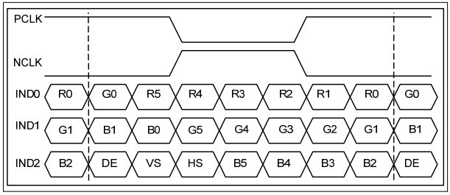

6.3.2 8Bit LVDS input
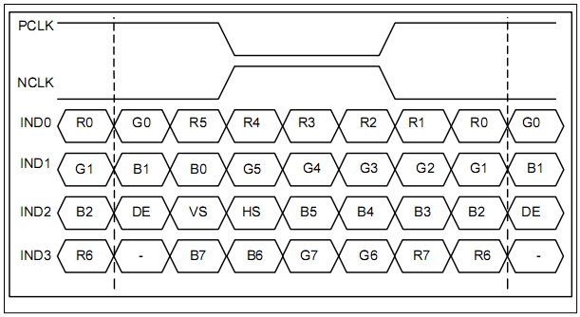

  - Interface Timing (DE mode)
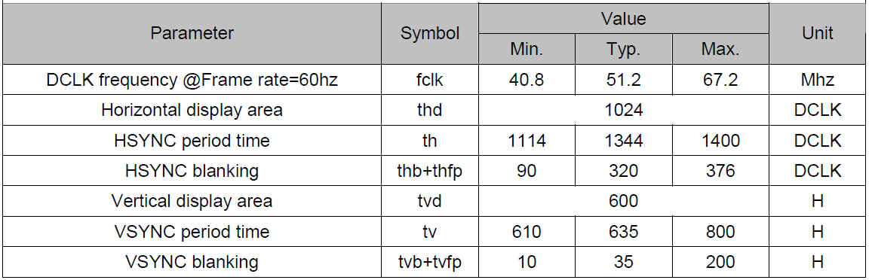

  - Power On / Off Sequence
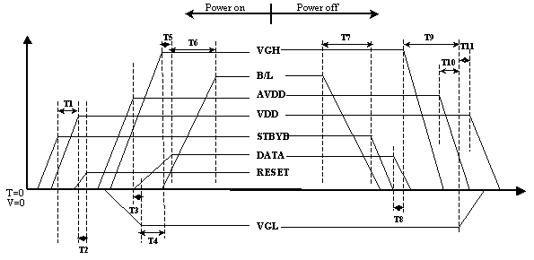

Item | Min. | Typ. | Max. | Unit
T1 | 0 | -- | -- | ms
T2 | 50 | -- | -- | ms
T3 | 5 | -- | -- | ms
T4 | 10 | -- | -- | ms
T5 | 20 | -- | -- | ms
T6 | 50 | -- | -- | ms
T7 | 20 | -- | -- | ms
T8 | 10 | -- | -- | ms
T9 | 20 | -- | -- | ms
T10 | 10 | -- | -- | ms
T11 | 20 | -- | -- | ms

  - Backlight Unit
Parameter | Symbol | Min | Typ | Max | Units | Condition
LED Current | I_{F} | -- | 240 | -- | mA | Ta=25℃
LED Voltage | V_{F} | -- -- | 9.6 | 10.2 | Volt | Ta=25℃
LED Life-Time | N/A | 10,000 | -- | -- | Hour | Ta=25℃  I_{F}=22.5mA  Note (2)

Note (1) LED life time (Hr) can be defined as the time in which it continues to operate under the condition: Ta=25±3 ºC, typical IL value indicated in the above table until the brightness becomes less than 50%.
Note (2) The “LED life time” is defined as the module brightness decrease to 50% original brightness at Ta=25℃ and IL=180mA. The LED lifetime could be decreased if operating IL is larger than 180mA. The constant current driving method is suggested.
Note (3) LED Light Bar Circuit

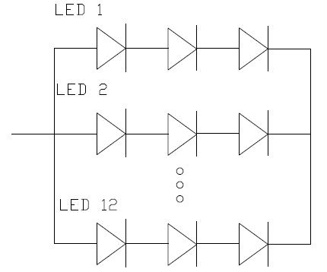

- Reliability test items
No. | Item | Conditions | Remark
1 | High Temperature Storage | Ta=+80ºC, 240hrs
2 | Low Temperature Storage | Ta=-30ºC, 240hrs
3 | High Temperature Operation | Ta=+70ºC, 240hrs
4 | Low Temperature Operation | Ta=-20ºC, 240hrs
5 | Thermal Cycling Test (non operation) | -20ºC(30min)→+70ºC(30min),100 cycles
6 | Vibration | Sine Wave  1.5G, 5~500Hz, XYZ  30min/each direction
7 | Shock | Half-Sine, 200G, 2ms, ±XYZ, 1time

Storage / Operating temperature

100
Humidity (%)

80

60
Operating Range
40
Storage Range

10

-20
20
40
-40
-60
Temperature (ºC)
-30
60
70

Note .Max wet bulb temp.=39ºC

- OUTLINE DIMENSION

  - Front View Outline Dimension Unit : mm
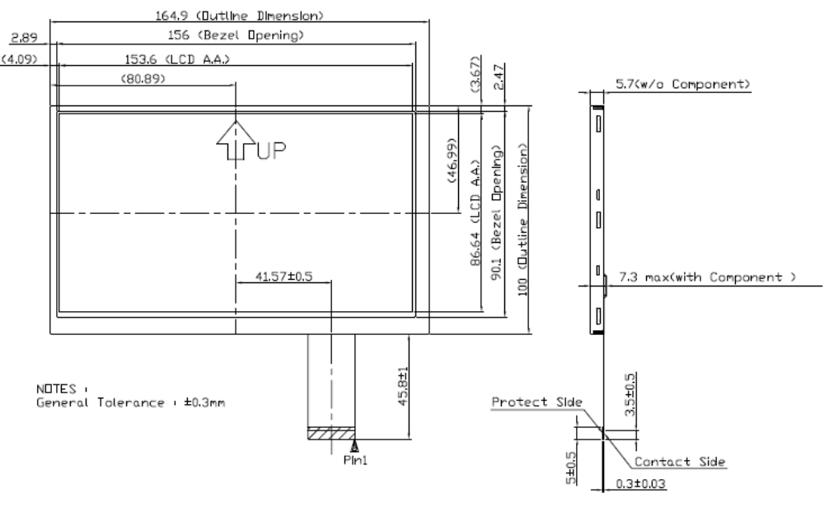

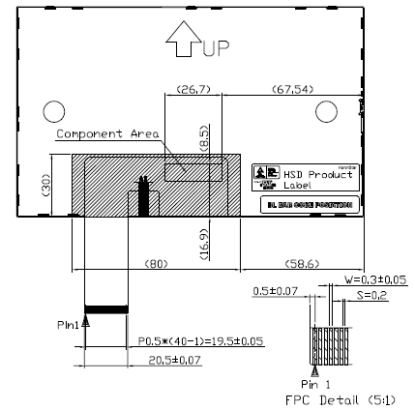

9.0 LOT MARK
9.1 Lot Mark

1 |  | 2 |  | 3 |  | 4 |  | 5 |  | 6 |  | 7 |  | 8 |  | 9 |  | 10 |  | 11 |  | 12 |  | 13 |  | 14 |  | 15

Code 1,2,3,4,5,6: HannStar internal flow control code.
Code 7: production location.
Code 8: production year.
Code 9: production month.
Code 10,11,12,13,14,15: serial number.

Note (1) Production Year
Year | 2006 | 2007 | 2008 | 2009 | 2010 | 2011 | 2012 | 2013 | 2014 | 2015
Mark | 6 | 7 | 8 | 9 | 0 | 1 | 2 | 3 | 4 | 5

Note (2) Production Month
Month | Jan. | Feb. | Mar. | Apr. | May. | Jun. | Jul. | Aug. | Sep. | Oct | Nov. | Dec.
Mark | 1 | 2 | 3 | 4 | 5 | 6 | 7 | 8 | 9 | A | B | C

  - Location of Lot Mark
- Location : The lot mark is attched to the back side of the LCD module. See Product back view. ( Section 8.0 : OUTLINE DIMENSION )
- Detail of the Lot mark: Print 15 code as lot mark (see 9.1 Lot Mark)
- This is subject to change without prior notice.

HSD070IFW1
Rev: * -A00

- PACKAGE SPECIFICATION
  - Packing form

LCM Model | LCM Qty. in the Box | Inner Box Size(mm) | Notice
HSD070IFW1-A00 | 80pcs/Box | 451mmx375mmx | --

  - Packing assembly drawings

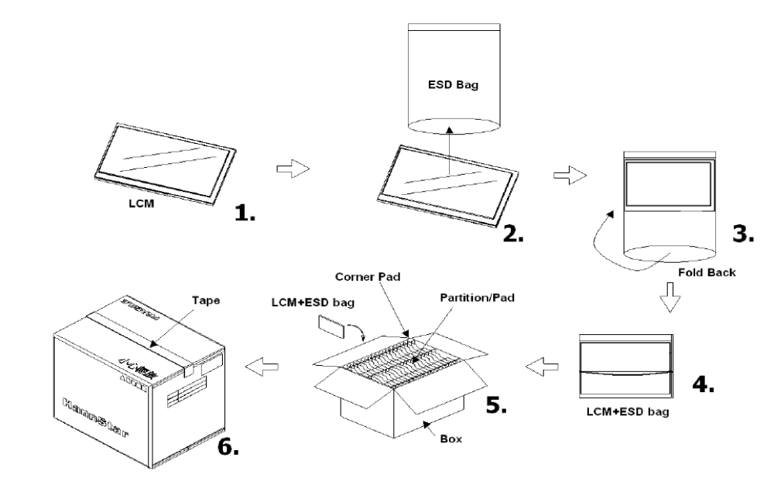

- GENERAL PRECAUTION
  - Use Restriction
This product is not authorized for use in life supporting systems, aircraft navigation control systems, military systems and any other application where performance failure could be life-threatening or otherwise catastrophic.

  - Disassembling or Modification
Do not disassemble or modify the module. It may damage sensitive parts inside LCD module, and may cause scratches or dust on the display. HannStar does not warrant the module, if customers disassemble or modify the module.

  - Breakage of LCD Panel
11.3.1.If LCD panel is broken and liquid crystal spills out, do not ingest or inhale liquid
crystal, and do not contact liquid crystal with skin.
    - If liquid crystal contacts mouth or eyes, rinse out with water immediately.
    - If liquid crystal contacts skin or cloths, wash it off immediately with alcohol and
rinse thoroughly with water.
    - Handle carefully with chips of glass that may cause injury, when the glass is
broken.

  - Electric Shock
    - Disconnect power supply before handling LCD module.
    - Do not pull or fold the LED cable.
    - Do not touch the parts inside LCD modules and the fluorescent LED’s connector
or cables in order to prevent electric shock.

  - Absolute Maximum Ratings and Power Protection Circuit
    - Do not exceed the absolute maximum rating values, such as the supply voltage
variation, input voltage variation, variation in parts’ parameters, environmental
temperature, etc., otherwise LCD module may be damaged.
    - Please do not leave LCD module in the environment of high humidity and high
temperature for a long time.
    - It’s recommended to employ protection circuit for power supply.

  - Operation
    - Do not touch, push or rub the polarizer with anything harder than HB pencil lead.
    - Use fingerstalls of soft gloves in order to keep clean display quality, when persons
handle the LCD module for incoming inspection or assembly.
    - When the surface is dusty, please wipe gently with absorbent cotton or other soft
material.

    - Wipe off saliva or water drops as soon as possible. If saliva or water drops contact with polarizer for a long time, they may causes deformation or color fading.
    - When cleaning the adhesives, please use absorbent cotton wetted with a little
petroleum benzine or other adequate solvent.

  - Mechanism
Please mount LCD module by using mounting holes arranged in four corners tightly.

  - Static Electricity
    - Protection film must remove very slowly from the surface of LCD module to
prevent from electrostatic occurrence.
11.8.2 Because LCD module use CMOS-IC on circuit board and TFT-LCD panel, it is very weak to electrostatic discharge. Please be careful with electrostatic discharge. Persons who handle the module should be grounded through adequate methods.

  - Strong Light Exposure
The module shall not be exposed under strong light such as direct sunlight. Otherwise,
display characteristics may be changed.

  - Disposal
When disposing LCD module, obey the local environmental regulations.

